In ARaymond Morocco, there are some additional costs that we want to include in the stock valuation. These costs are not planned in the PO. There can be different VAT rates

- Header data
Choose Transaction type 3-Subsequent Debit and Adjust the currency
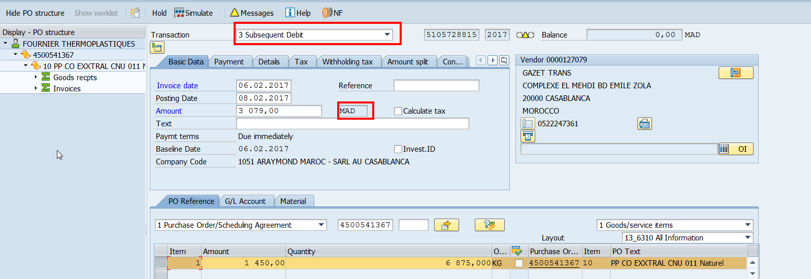

Select the supplier
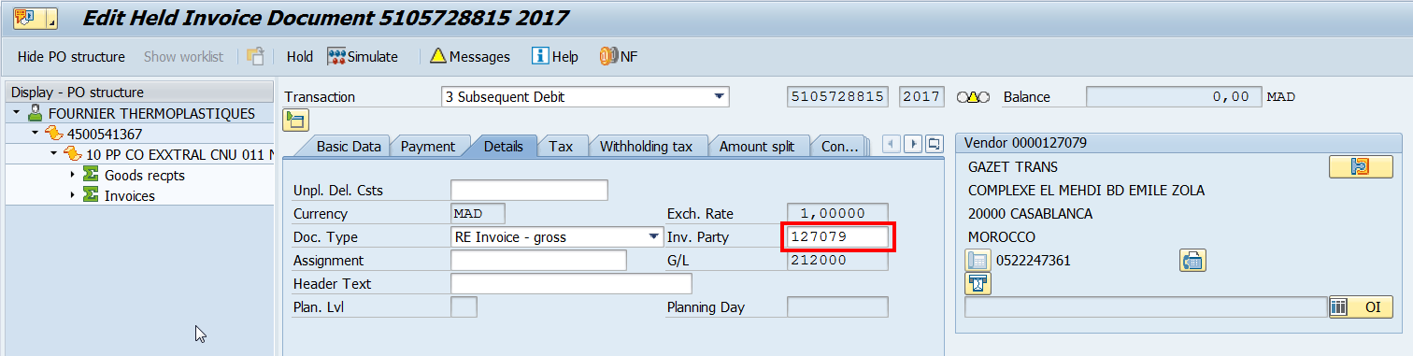

Enter the VAT amounts
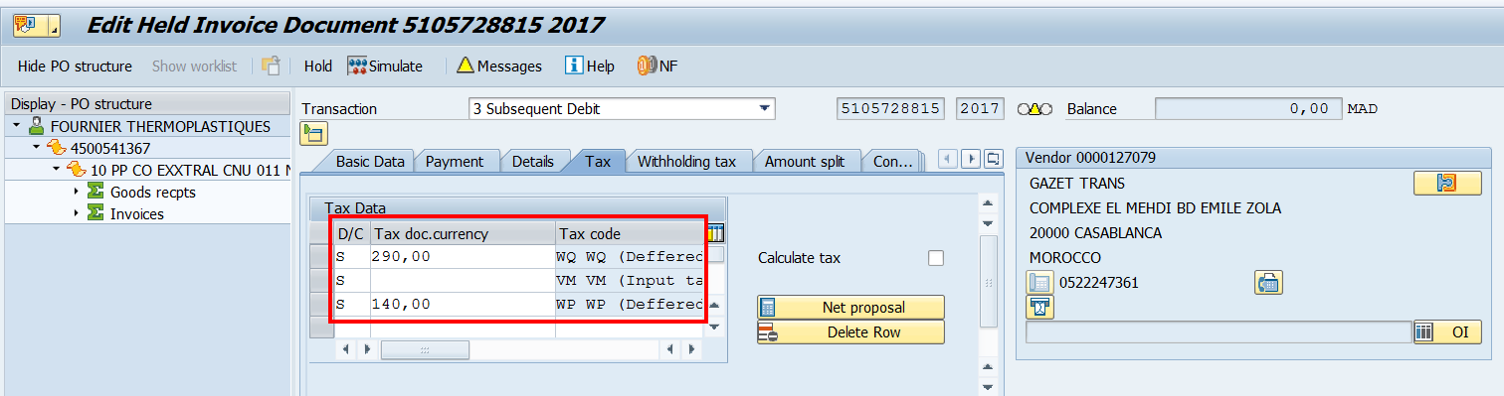

- Line item data
On the PO tab, enter the amount corresponding to one of the VAT rates that must be included on the stock valuation
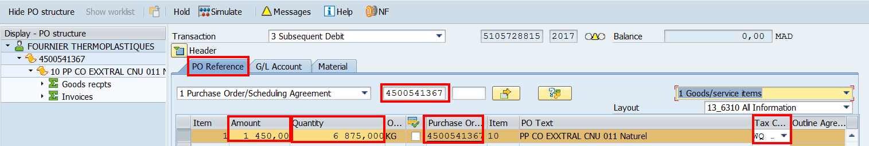

On the GL Account tab, enter the amount(s) that must not be included in the stock valuation
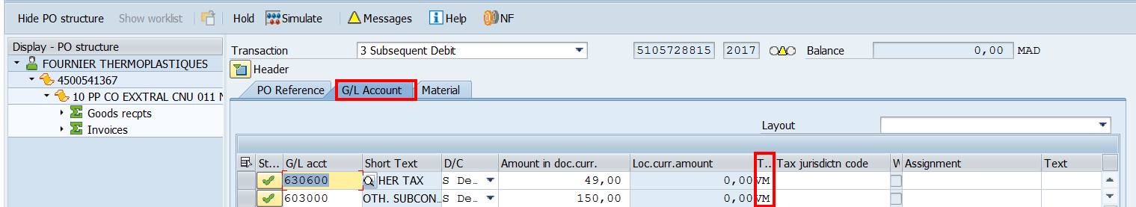

On the Material tab, enter the amount corresponding to the second VAT rate that must be included on the stock valuation (be careful of the quantity)
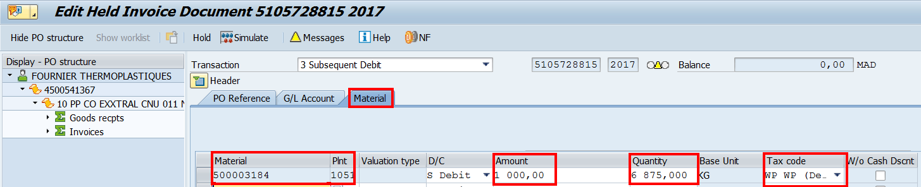

3) Simulate the posting and post. The invoice will be posted blocked for payment for price discrepancy
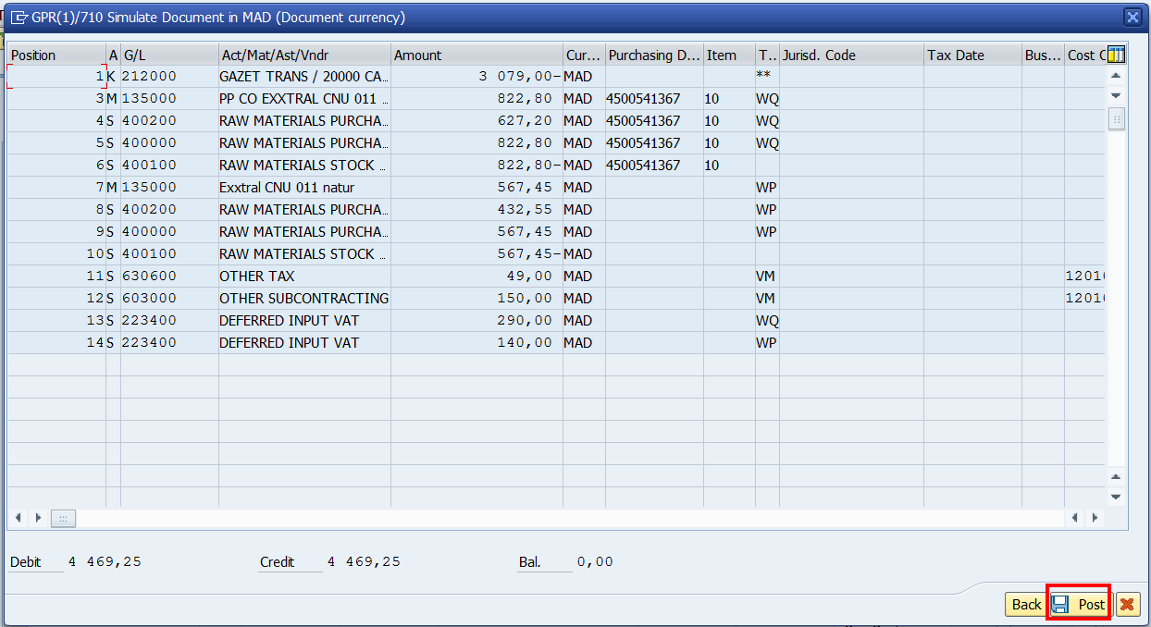

- Unblocked the invoice in MRBR
